
National University Of Modern Languages, Islamabad

User Experience Design (UXD)

Lab Task 3
Task: University Website’s Information Architecture
Name: Zulqarnain Hassan
Class: 6A Afternoon
Roll no: SP-21379
Assigned Date: 20 Feb 2025
Deadline: 23 Feb 2025
Figma Design Link: https://www.figma.com/design/5jCtVxiOwlpKD2tyHX7IhI/Untitled?node-id=0-1&m=dev&t=cjHCkLIY5199f5kU-1

Marks Obtained
Remarks

Issues:

Design Screenshots:
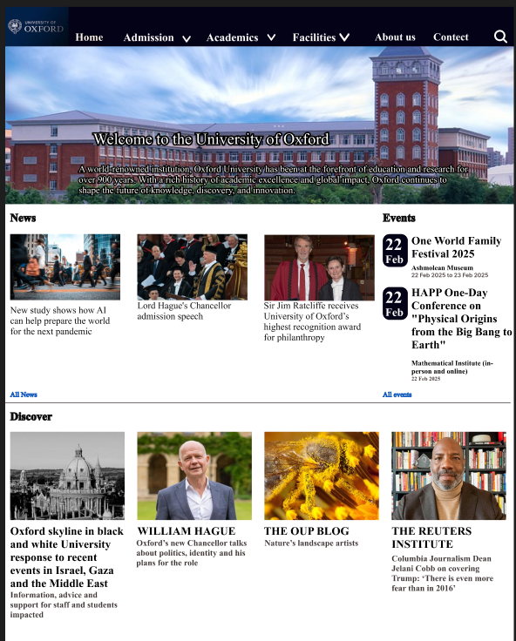

With dropdowns
